|  |  |  |
| --- | --- | --- |
| **logo-removebg-preview.png** | **TRAFFIC MANAGEMENT** | **logo.13a0474.png** |

**PROJECT REPORT**

**Submitted by**

**AARTHI S 811221106001**

**AROCKIA JENIFER M 811221106003**

**DHINESH BABU C 811221106008**

**THAMILARASI C 811221106033**

**VELLAISAMY S 811221106036**

**BACHELER OF ENGINEERING**

**IN**

**ELECTRONICS AND COMUNICATION ENGINEERING**

**INDRA GANESAN COLLEGE OF ENGINEERING,TRICHY**

**NAN MUTHALVAN**

**ABSTRACT:**

Traffic congestion is a major problem in many cities of India along with other countries. Failure

of signals, poor law enforcement and bad traffic management has lead to traffic congestion. One of the

major problems with Indian cities is that the existing infrastructure cannot be expanded more, and

the only option available is better management of the traffic. Traffic congestion has a negative impact

on economy, the environment and the overall quality of life. Hence it is high time to effectively manage

the traffic congestion problem. There are various methods available for traffic management such as

RFID, infrared sensors, inductive loop detection, wireless sensor network, etc. All these methods are

effective methods of smart traffic management. But the problem with these systems is that the

installation time, the cost incurred for the installation and maintenance of the system is very high.

Hence a new technology using image processing with IOT is introduced which can be coupled with the

existing signaling system that can act as a key to smart traffic management in real time. This new

technology which will require less time for installation with lesser costs as compared to other methods

of traffic congestion management. Use of this new technology will lead to reduced traffic congestion.

**LITERATURE SURVEY:**

1. **Smart Traffic management system using IOT**

Naresh K S1 , Francis J kalliath2

ABSTRACT:

Traffic is a major obstacle faced by all metropolitan cities; this is due to the exponential increase in

number of vehicles on the road but the infrastructure for road transportation remains the same. The

average travelling time consumption by people is increasing year by year for the same given way points.

Most of the cities still rely on conventional traffic signaling which is controlled manually or time based.

This conventional system used around the world is not efficient as it lacks useful data from reliable real-

time sources to clear the way for emergency vehicles (ambulances, firetrucks and police vehicles) during

consumption and leads to health issues. Due to this Traffic flowing to a junction from all the directions at

a given time is unequal. A smart traffic management is a system, where traffic is controlled by the

management system, which controls the traffic lights in accordance with the real time situation of traffic

moving from all different directions in a junction. This real time data is collected either from google

maps (future work) or from various sensors placed at equal intervals of distance at a junction. This data

is collected and brought to a control system which autonomously calculates the optimum time for the

release of the green signal. We are aiming to solve the issue of traffic by efficiently controlling the

signaled intersections in cities by presenting present an algorithm based on comparative real time data

analysis using IOT [2]. Considering this review, we identify a range of important possibilities for

contributions to traffic management, detection technology and flexible optimization techniques that use

various kinds of automated learning.

LIMITATIONS:

* Traffic Conjecction.
* No means to detect traffic conjection.
* It requires more manpower

**2)TRAFFIC MANAGEMENT SYSTEM USING IOT**

1.SANJAY KUMAR SAHU, 2.ATUL BASANT

ABSTRACT:

Traffic management system is one of the major proportions of a smart city. With the rapid growth of

population and rapid increase of vehicles across the whole country which further leads to the traffic

Congestion which is usually seen on roads. Nowadays traffic congestion is a difficult issue to deal with as

number of vehicles is increasing day by day. To tackle various issues of traffic on roads and to help

authorities in proper planning, a smart traffic management system using the Internet of Things (IoT) is

proposed in this paper. A simple, effective and less costly method is used to optimize traffic flow on

roads and an algorithm is devised to manage various traffic situations efficiently and automatically. For

this purpose, the system takes traffic density as input from 8 different sensors which are there in 4 lanes

which manages traffic signals. Besides this manual control of this system using Wi-Fi is also used to

prioritize the emergency vehicles such as ambulances and fire brigade vehicles during a traffic jam, so

that we can open the specific lane with the remote using Wi-Fi. To show the effectiveness of this

proposed traffic management system, a prototype is developed which optimizes the traffic having lesser

cost and is very effective. And the real time data will also be visible in the mobile phone through

application.

LIMITATIONS:

* It may be affected by external interfering magnetic field.
* Large temperature drift.

**3)IOT Based Traffic Management System**

Shashank S1, Kiran P1

**ABSTRACT:**

In 2014, 54% of the total global population was urban residents. The prediction was a growth of nearly

2% each year until 2020 leading to more pressure on the transportation system of cities. Cities should

be making their streets run smarter instead of just making them bigger or building more roads. This

leads to the proposed system which will use a Raspberry pi and Camera for tracking the number of

vehicles leading to time-based monitoring of the system.

**LIMITATIONS:**

* Number of accidents are more.
* It is less economical.
* It is not efficient.

**EXECUTE BLOCK DIAGRAM:**

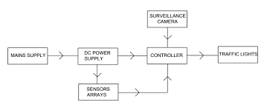

**PROPOSED BLOCK DIAGRAM:**

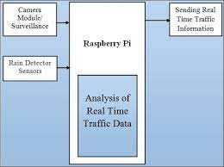

**HARDWARE COMPONENTS:**

* 4 Green LED
* 4 Red LED
* 4 Yellow LED
* Arduino Board
* Camera
* Connecting wires
* Breadboard
* 12 Resistor-220 Ohms

**SOFTWARE COMPONENTS:**

* Wokwi

**CIRCUIT DIAGRAM:**

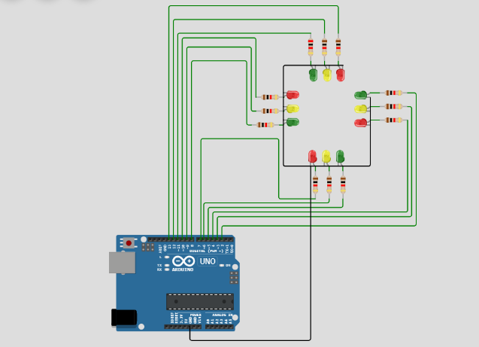

**DESCRIPTION:**

TMS include, ramp signaling, dynamic lane management, variable speed limits, incident

detection, vehicle activated signs and adaptive traffic signal control. Many of the systems are

usually integrated to gain maximum benefit.

**FLOW DIAGRAM:**

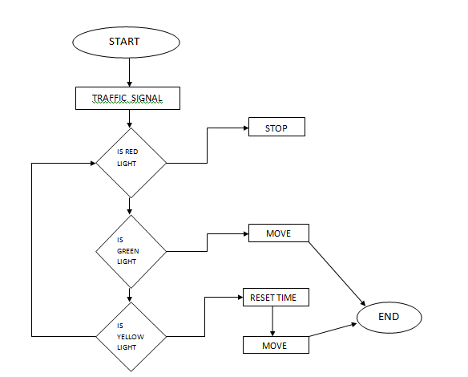

**PROGRAM:**

int Lane1[] = {13,12,11}; // Lane 1 Red, Yellow and Green

int Lane2[] = {10,9,8};     // Lane 2 Red, Yellow and Green

int Lane3[] = {7,6,5};       // Lane 3 Red, Yellow and Green

int Lane4[] = {4,3,2};       // Lane 4 Red, Yellow and Green

void setup()

{

for (int i = 0; i < 3; i++)

{

pinMode(Lane1[i], OUTPUT);

pinMode(Lane2[i], OUTPUT);

pinMode(Lane3[i], OUTPUT);

pinMode(Lane4[i], OUTPUT);

}

for (int i = 0; i < 3; i++)

{

digitalWrite(Lane1[i], LOW);

digitalWrite(Lane2[i], LOW);

digitalWrite(Lane3[i], LOW);

digitalWrite(Lane4[i], LOW);

}

}

void loop()

{

digitalWrite(Lane1[2], HIGH);

digitalWrite(Lane3[0], HIGH);

digitalWrite(Lane4[0], HIGH);

digitalWrite(Lane2[0], HIGH);

delay(7000);

digitalWrite(Lane1[2], LOW);

digitalWrite(Lane3[0], LOW);

digitalWrite(Lane1[1], HIGH);

digitalWrite(Lane3[1], HIGH);

delay(3000);

digitalWrite(Lane1[1], LOW);

digitalWrite(Lane3[1], LOW);

digitalWrite(Lane1[0], HIGH);

digitalWrite(Lane3[2], HIGH);

delay(7000);

digitalWrite(Lane3[2], LOW);

digitalWrite(Lane4[0], LOW);

digitalWrite(Lane3[1], HIGH);

digitalWrite(Lane4[1], HIGH);

delay(3000);

digitalWrite(Lane3[1], LOW);

digitalWrite(Lane4[1], LOW);

digitalWrite(Lane3[0], HIGH);

digitalWrite(Lane4[2], HIGH);

delay(7000);

digitalWrite(Lane4[2], LOW);

digitalWrite(Lane2[0], LOW);

digitalWrite(Lane4[1], HIGH);

digitalWrite(Lane2[1], HIGH);

delay(3000);

digitalWrite(Lane4[1], LOW);

digitalWrite(Lane2[1], LOW);

digitalWrite(Lane4[0], HIGH);

digitalWrite(Lane2[2], HIGH);

delay(7000);

digitalWrite(Lane1[0], LOW);

digitalWrite(Lane2[2], LOW);

digitalWrite(Lane1[1], HIGH);

digitalWrite(Lane2[1], HIGH);

delay(3000);

digitalWrite(Lane2[1], LOW);

digitalWrite(Lane1[1], LOW);

}

**OUTPUT:**

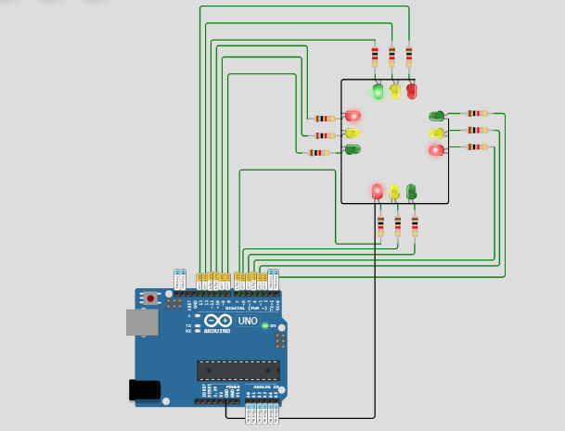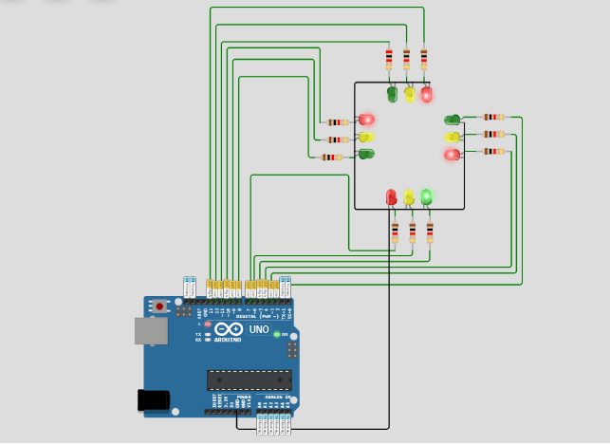

**CONCLUSION:**

Smart Traffic Management System has been developed by using multiple features of hardware

components in IoT. Traffic optimization is achieved using IoT platform for efficient utilizing allocating

varying time to all traffic signal according to available vehicles count in road path.

It changes the signal timing intelligently according to traffic density on the particular roadside and

regulates traffic flow by communicating with local server more effectively than ever before. The

decentralized approach makes it optimized and effective as the system works even if a local server or

centralized server has crashed. The system also provides useful information to higher authorities that

can be used in road planning which helps in optimal usage of resources.

**FUTURE SCOPE:**

* An Internet of Things (IoT)-enabled intelligent traffic management system can solve

pertinent issues by leveraging technologies like wireless connectivity & intelligent

sensors. Considered a cornerstone of a smart city, they help improve the comfort and

safety of drivers, passengers & pedestrians.

* These systems use technology to make our commutes smoother and less stressful.

According Market.us The Global Intelligent Traffic Management System Market in terms

of revenue was estimated to be worth USD 10.0 Bn in 2022 and is poised to reach USD

24.9 Bn by 2032, growing at a CAGR of 9.8% from 2023 to 2032.

**REFERENCE:**

[1] 21st Century operations Using 21st Century Technologies. U.S Department Of transportation Federal Highway Administration.2008-08-29. Retrieved 2008-09-25. <http://www.ops.fhwa.dot.gov/aboutus/opstory.htm>

[2] William Beaty. Jan 1998. Traffic Waves ―Sometimes one driver can vastly improve traffic‖. <http://www.amasci.com/amateur/traffic/traffic1.html>

[3] Dipak K Dash, TNN May 31, 2012. ―India loses Rs 60,000 crore due to traffic congestion: Study‖. Times Of India. <http://articles.timesofindia.indiatimes.com/2012-05-31/india/31920307_1_toll-plazas-road-spacestoppage>

[4] Azeem Uddin, Draft, 23 March 2009. Traffic congestion in Indian cities: Challenges of a Rising power. http://www.visionwebsite.eu/UserFiles/File/filedascaricare/Scientifci%20Partners,Papers%28Kyoto%29/Draft_ koc_Azeem%20Uddin.pdf

[5] FHWA-HRT-06-108. October 2006. Traffic Detector Handbook: Third Edition—Volume I. <http://www.fhwa.dot.gov/publications/research/operations/its/06108/>